**Descriptive Title of Your Thesis Project**

**Student Name**

**Submitted to the Department of Chemistry of Lehigh University in partial fulfillment of the requirements for the degree of Bachelor of Science (or Bachelor of Arts) with honors**

**Faculty Advisor: Prof 1**

**Thesis Committee: Prof 2, Prof 3**

***Month Day, Year***

Dedication if desired

(1 page or less)

Use the following formatting for the remainder of the thesis document:

**For the main body text, use the “Normal” style:**

* font Cambria,
* 12-point font,
* Justified,
* Double spaced

**For Figures and Table, use “Caption” style**:

* font Cambria,
* 10-point font,
* Justified,
* Single spaced

**For Headings, use “Heading 1” or “Heading 2” styles:**

* font Cambria,
* 16 or 13-point font, respectively

# ACKNOWLEDGEMENTS

Lorem ipsum dolor sit amet, consectetur adipiscing elit, sed do eiusmod tempor incididunt ut labore et dolore magna aliqua. ...

(keep to 1 page or less)

# GRAPHICAL ABSTRACT

Include a graphical abstract for your thesis. A graphical abstract is a single, concise, pictorial, and visual summary of the main findings of the article. It could either be the concluding figure or, better yet, a figure specially designed to capture the content of the thesis for readers at a glance. ABSTRACT

Lorem ipsum dolor sit amet, consectetur adipiscing elit, sed do eiusmod tempor incididunt ut labore et dolore magna aliqua. Ut enim ad minim veniam, quis nostrud exercitation ullamco laboris nisi ut aliquip ex ea commodo consequat. Duis aute irure dolor in reprehenderit in voluptate velit esse cillum dolore eu fugiat nulla pariatur. Excepteur sint occaecat cupidatat non proident, sunt in culpa qui officia deserunt mollit anim id est laborum.

1 page or less.

The abstract summarizes the motivation and results of the experiment and states any significant conclusions. Numerical results with confidence limits should be included in prose form. Abstracts are typically 100-200 words in length. Do not show tabulated data. Do not cite any references.

# TABLE OF CONTENTS

ACKNOWLEDGEMENTS 3

GRAPHICAL ABSTRACT 4

TABLE OF CONTENTS 6

LIST OF FIGURES 7

LIST OF TABLES 8

LIST OF ABBREVIATIONS 9

CHAPTER I: INTRODUCTION 10

First Sub-section of the Chapter 10

Second Sub-section of the Chapter 11

CHAPTER II: MATERIALS AND METHODS 12

Materials 12

Instrumentation 12

Physical Measurements or Synthetic Details 13

CHAPTER III: RESULTS AND DISCUSSION 14

First Sub-section of the Chapter 14

Second Sub-section of the Chapter 15

Guidelines for Numbers, Equations, Figures, and Captions in the Thesis 15

CHAPTER IV: CONCLUSION AND FUTURE DIRECTIONS 19

First Sub-section of the Chapter 19

CHAPTER V: REFLECTIONS 20

REFERENCES 21

# LIST OF FIGURES

**Figure 1**. Lorem ipsum dolor sit amet. 10

**Figure 2**. Lorem ipsum dolor sit amet. 14

**Figure 3**. Natural log of the concentration of reactant as a function of time. The error bars for time are smaller than the marker size. The data are fitted (blue line) to an equation $lnC=At+B$, where coefficients are $A=value±error$ and $B=value±error$. 17

The List of Figures will automatically populate if the Figure caption is inserted as a “References 🡪 insert caption” OR if copied/pasted from an existing Figure from the template, as described below. To update the table, right-click on the list and select the “Update Field” Option, then choose the option for “Update entire table”.

# LIST OF TABLES

**Table 1**. Lorem ipsum dolor sit amet 11

**Table 2**. Lorem ipsum dolor sit amet 15

**Table 3**. Conductivity of sodium acetate solutions 18

The List of Tables will automatically populate if the Table caption is inserted as a “References 🡪 insert caption” OR if copied/pasted from an existing Table from the template, as described below. To update the table, right-click on the list and select the “Update Field” Option, then choose the option for “Update entire table”.

# LIST OF ABBREVIATIONS

LI – Lorem ipsum

LIDS – Lorem ipsum dolor sit

# CHAPTER I: INTRODUCTION

Lorem ipsum dolor sit amet, consectetur adipiscing elit, sed do eiusmod tempor incididunt ut labore et dolore magna aliqua. Ut enim ad minim veniam, quis nostrud exercitation ullamco laboris nisi ut aliquip ex ea commodo consequat. Duis aute irure dolor in reprehenderit in voluptate velit esse cillum dolore eu fugiat nulla pariatur. Excepteur sint occaecat cupidatat non proident, sunt in culpa qui officia deserunt mollit anim id est laborum.

Include the first paragraph to introduce the Introduction Chapter.

## First Sub-section of the Chapter

Lorem ipsum dolor sit amet, consectetur adipiscing elit, sed do eiusmod tempor incididunt ut labore et dolore magna aliqua. Ut enim ad minim veniam, quis nostrud exercitation ullamco laboris nisi ut aliquip ex ea commodo consequat. Duis aute irure dolor in reprehenderit in voluptate velit esse cillum dolore eu fugiat nulla pariatur. Excepteur sint occaecat cupidatat non proident, sunt in culpa qui officia deserunt mollit anim id est laborum.

(include a figure)

**Figure 1**. Lorem ipsum dolor sit amet.

To add more figures, Use Reference🡪Inset Caption🡪 and choose Figure Caption. Put Figure and caption in a textbox. OR copy/paste this example box. Figure titles go at the bottom of the figure and are left-aligned.

Write about the first topic of the introduction.

**Table 1**. Lorem ipsum dolor sit amet

(include a Table)

To add more tables, Use Reference🡪Inset Caption🡪 and choose Table. Put table and caption in a textbox. OR copy/paste this example. Table titles go at the top of the table and are left-aligned.

## Second Sub-section of the Chapter

Lorem ipsum dolor sit amet, consectetur adipiscing elit, sed do eiusmod tempor incididunt ut labore et dolore magna aliqua. Ut enim ad minim veniam, quis nostrud exercitation ullamco laboris nisi ut aliquip ex ea commodo consequat. Duis aute irure dolor in reprehenderit in voluptate velit esse cillum dolore eu fugiat nulla pariatur. Excepteur sint occaecat cupidatat non proident, sunt in culpa qui officia deserunt mollit anim id est laborum.

Continue to write about the topics for the introduction. Add additional Sub-section headings as needed. Use the “Heading 2” Style or copy and paste another sub-heading so the TOC will automatically update. Add additional Figures and Tables as needed, following the instructions above.

# CHAPTER II: MATERIALS AND METHODS

## Materials

Lorem ipsum dolor sit amet, consectetur adipiscing elit, sed do eiusmod tempor incididunt ut labore et dolore magna aliqua. Ut enim ad minim veniam, quis nostrud exercitation ullamco laboris nisi ut aliquip ex ea commodo consequat. Duis aute irure dolor in reprehenderit in voluptate velit esse cillum dolore eu fugiat nulla pariatur. Excepteur sint occaecat cupidatat non proident, sunt in culpa qui officia deserunt mollit anim id est laborum.

Materials and/or sample preparation details are included here.

## Instrumentation

Lorem ipsum dolor sit amet, consectetur adipiscing elit, sed do eiusmod tempor incididunt ut labore et dolore magna aliqua. Ut enim ad minim veniam, quis nostrud exercitation ullamco laboris nisi ut aliquip ex ea commodo consequat. Duis aute irure dolor in reprehenderit in voluptate velit esse cillum dolore eu fugiat nulla pariatur. Excepteur sint occaecat cupidatat non proident, sunt in culpa qui officia deserunt mollit anim id est laborum.

Include instruments, including the make and model for equipment used in the thesis.

## Physical Measurements or Synthetic Details

Lorem ipsum dolor sit amet, consectetur adipiscing elit, sed do eiusmod tempor incididunt ut labore et dolore magna aliqua. Ut enim ad minim veniam, quis nostrud exercitation ullamco laboris nisi ut aliquip ex ea commodo consequat. Duis aute irure dolor in reprehenderit in voluptate velit esse cillum dolore eu fugiat nulla pariatur. Excepteur sint occaecat cupidatat non proident, sunt in culpa qui officia deserunt mollit anim id est laborum.

Include additional subsections that describe the experiments and methods used in the thesis so that another scientist can reproduce your experiments. These would be details of syntheses, characterization of products, experiments like electrochemistry, spectroscopy, titrations, temperature-dependent measurements, and computational details. There should be no figures in this section.

# CHAPTER III: RESULTS AND DISCUSSION

Lorem ipsum dolor sit amet, consectetur adipiscing elit, sed do eiusmod tempor incididunt ut labore et dolore magna aliqua. Ut enim ad minim veniam, quis nostrud exercitation ullamco laboris nisi ut aliquip ex ea commodo consequat. Duis aute irure dolor in reprehenderit in voluptate velit esse cillum dolore eu fugiat nulla pariatur. Excepteur sint occaecat cupidatat non proident, sunt in culpa qui officia deserunt mollit anim id est laborum.

Initial introduction to the chapter.

## First Sub-section of the Chapter

Lorem ipsum dolor sit amet, consectetur adipiscing elit, sed do eiusmod tempor incididunt ut labore et dolore magna aliqua. Ut enim ad minim veniam, quis nostrud exercitation ullamco laboris nisi ut aliquip ex ea commodo consequat. Duis aute irure dolor in reprehenderit in voluptate velit esse cillum dolore eu fugiat nulla pariatur. Excepteur sint occaecat cupidatat non proident, sunt in culpa qui officia deserunt mollit anim id est laborum.

Write about the first topic.

(include a figure)

**Figure 2**. Lorem ipsum dolor sit amet.

To add more figures, Use Reference🡪Inset Caption🡪 and choose Figure Caption. Put Figure and caption in a textbox.

## Second Sub-section of the Chapter

Lorem ipsum dolor sit amet, consectetur adipiscing elit, sed do eiusmod tempor incididunt ut labore et dolore magna aliqua. Ut enim ad minim veniam, quis nostrud exercitation ullamco laboris nisi ut aliquip ex ea commodo consequat. Duis aute irure dolor in reprehenderit in voluptate velit esse cillum dolore eu fugiat nulla pariatur. Excepteur sint occaecat cupidatat non proident, sunt in culpa qui officia deserunt mollit anim id est laborum.

Add additional Sub-section headings as needed. Use the “Heading 2” Style or copy and paste another sub-heading so the TOC will automatically update. Add additional Figures as needed, and be sure to use the Insert Caption feature).

## Guidelines for Numbers, Equations, Figures, and Captions in the Thesis

**Table 2**. Lorem ipsum dolor sit amet

(include a Table)

To add more tables, Use Reference🡪Inset Caption🡪 and choose Table Put table and caption in a textbox. Table titles go at the top of the table and are left aligned.

* *Numbers*: When **using scientific notation** for small values, the measured and precision values should share a common exponent, e.g. $\left(1.09±0.03\right)×{10}^{-2}$. The following examples (with units added) show **acceptable formatting**: 4.663 ± 0.016 kg; 108 ± 3 kJ/mol; $\left(7.91±0.06\right)×{10}^{-3}$ s or 7.91 ± 0.06 ms.
* *Equations*: **Each equation** **should appear on a separate line** and should be part of a complete sentence, usually ending in a comma,

|  |  |
| --- | --- |
| $$f\left(x\right)=a_{0}+\sum_{n=1}^{∞}{\left(a_{n}\cos{\frac{nπx}{L}}+b_{n}\sin{\frac{nπx}{L}}\right)}$$ | (1) |

**Number all equations** consecutively using (parentheses) throughout the entire report and refer to them by their number in the text (*i.e.,* Equation 1). The numbers should appear adjacent to the right-hand margin. **Typeset your equations** using Microsoft Word’s Equation Editor or an equivalent tool (e.g., LaTeX).

* *Figures:* Each figure should be **numbered in bold font** and given a descriptive caption **positioned below the figure.** Figures and captions should be placed within a textbox. Text wrapping around the figure can be used; do not include a box around the textbox.Use a smaller font size and single-space figure captions to separate them from the main text visually. The figure caption should be Justified within the textbox. Label all axes. Indicate clearly the units used. Error bars should be included when the uncertainties are greater than the size of the symbols enclosing the points. Should error bars be smaller than the size of the symbols for any data set shown, state this fact explicitly in the figure captions.

Use appropriate text wrapping features to ensure good use of space. Avoid placing extraneous information on the figure (such as fit coefficients), except for a legend (for multiple curves and datasets). Report this information in figure captions or main text.

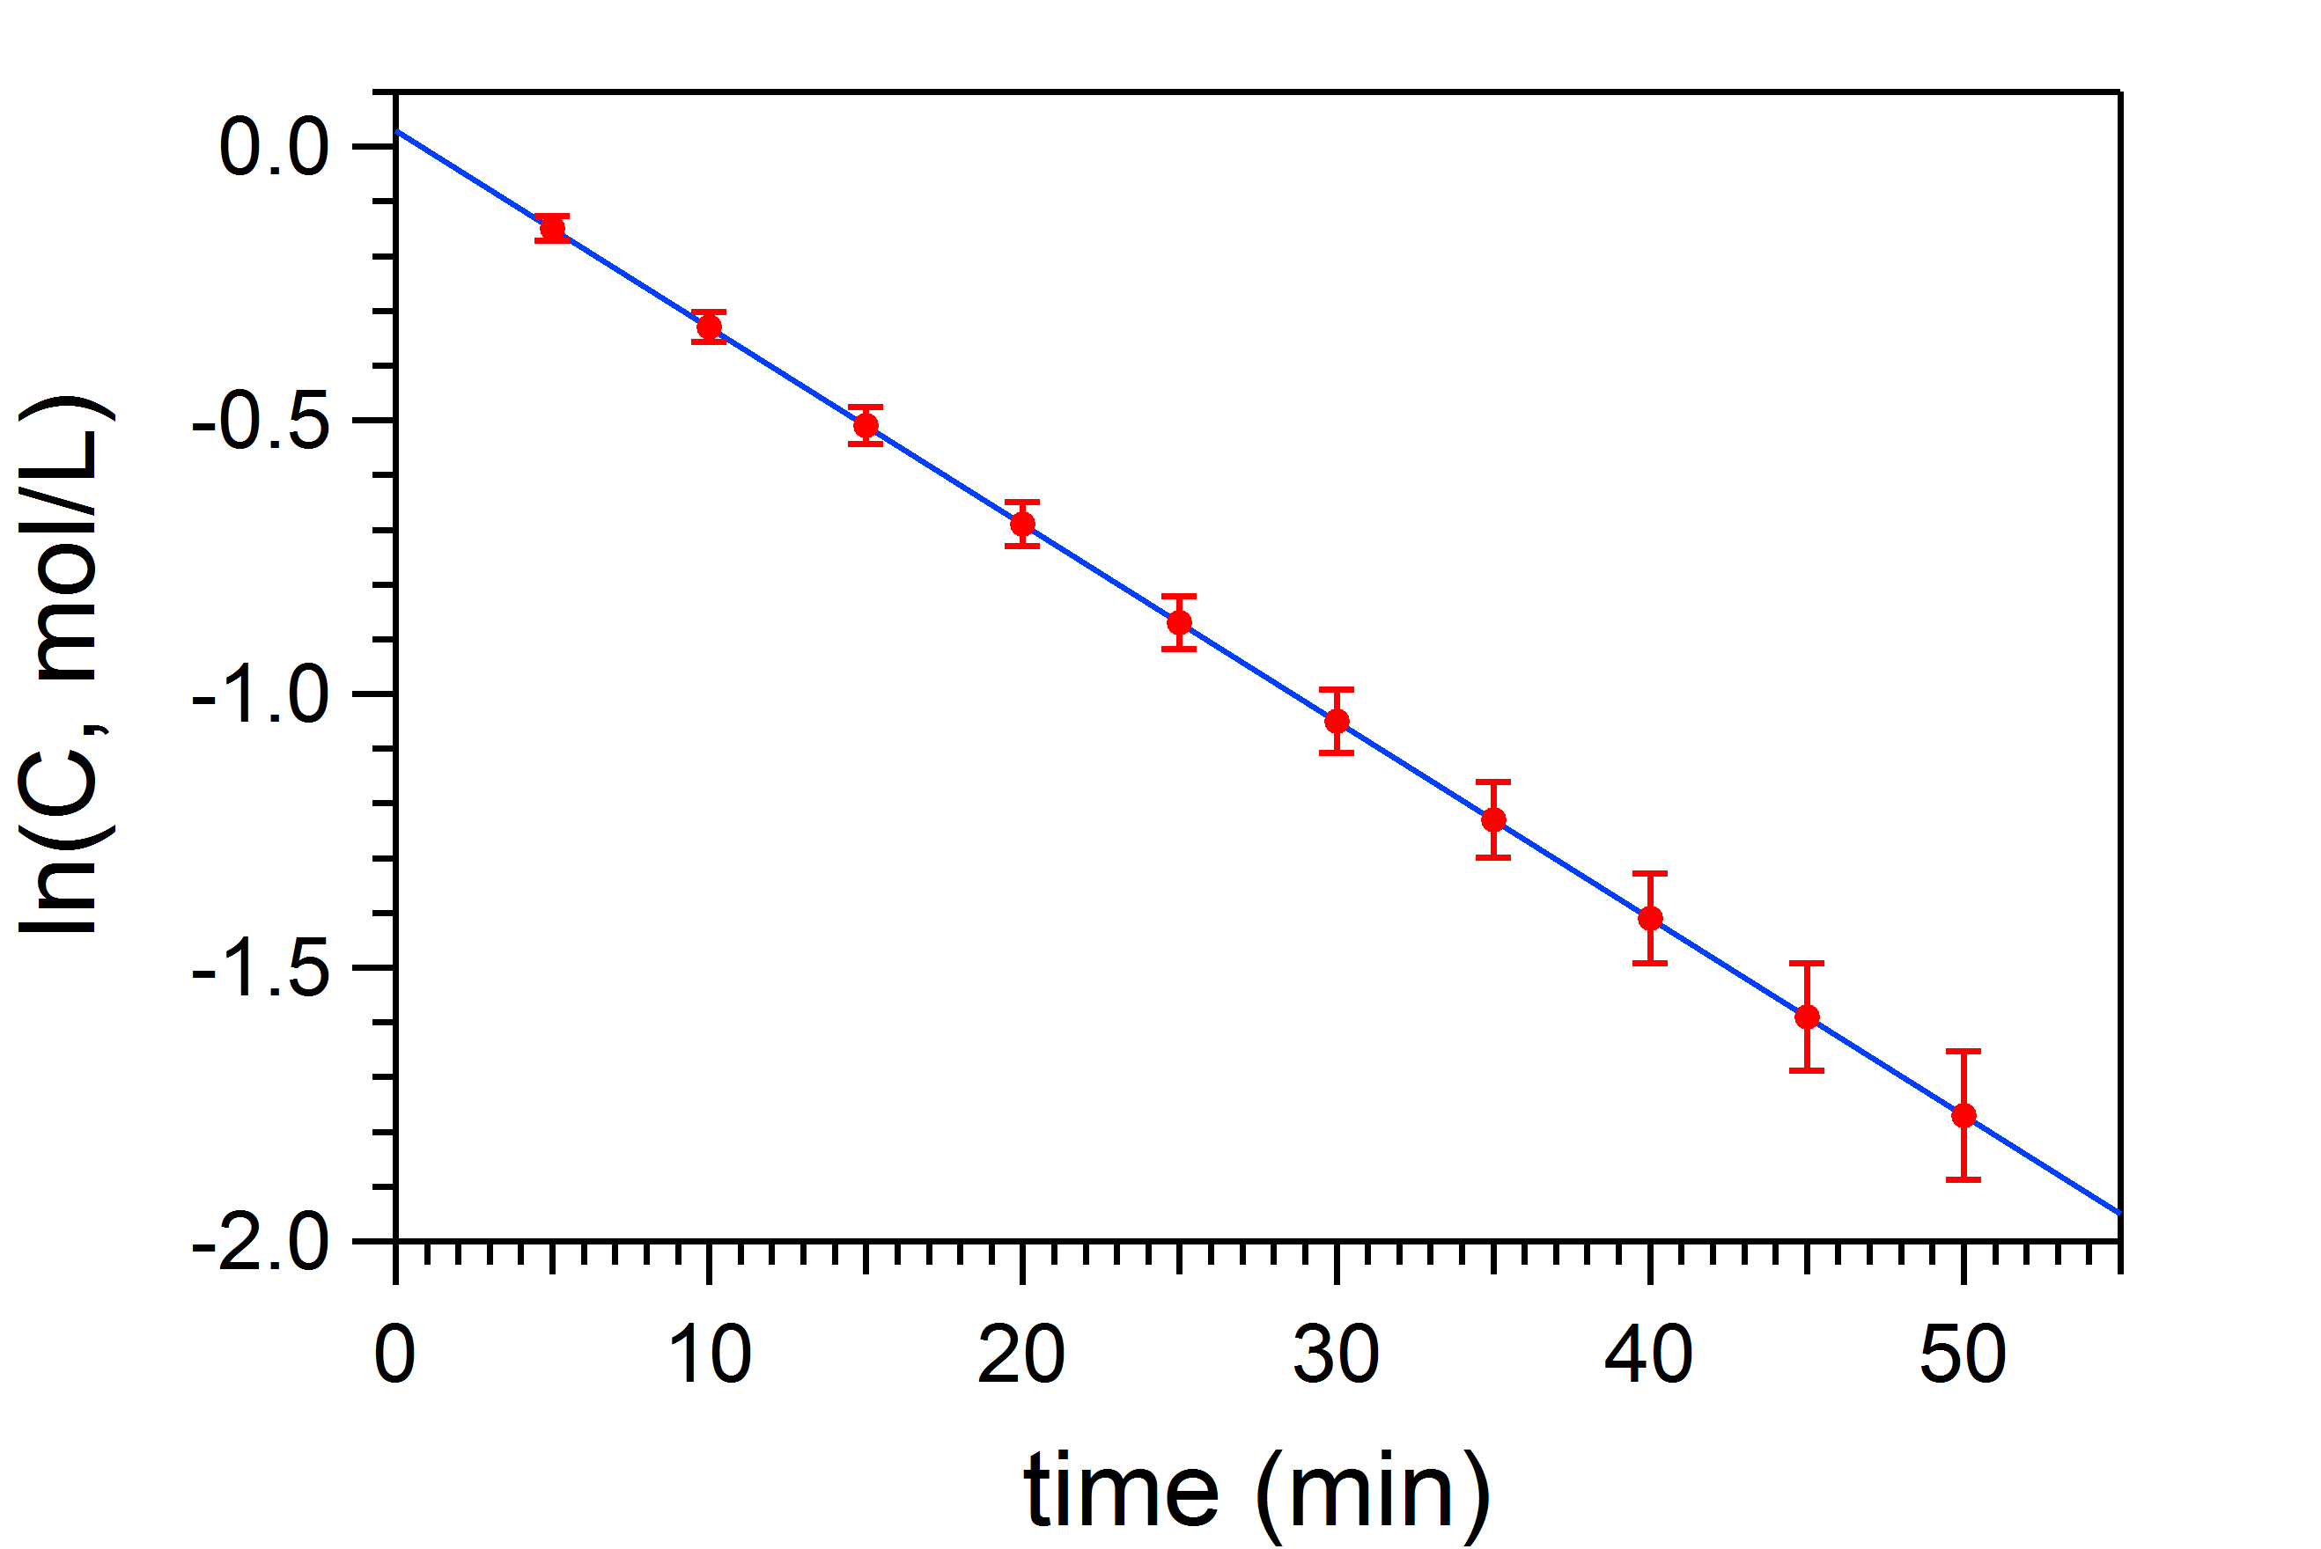

**Figure 3**. Natural log of the concentration of reactant as a function of time. The error bars for time are smaller than the marker size. The data are fitted (blue line) to an equation $\ln{C}=At+B$, where coefficients are $A=value±error$ and $B=value±error$.

* *Tables*: All tables must be **numbered in bold font** and have a descriptive title **positioned above the table.** Increase the font size and single-space table titles to separate them visually from the main text. The quantities displayed in a table should be **clearly labeled with units specified** (preferably in the column header rather than individually). The use of symbols is often insufficient (*i.e.,* use “Temperature” rather than “T”).

**Table 3**. Conductivity of sodium acetate solutions

|  |  |
| --- | --- |
| **Concentration c, M** | **Conductivity Ω, S∙m2/mol** |
| 0.0005 | 0.0109 ± 0.0003 |
| 0.0050 | 0.0070 ± 0.0005 |

# CHAPTER IV: CONCLUSION AND FUTURE DIRECTIONS

Lorem ipsum dolor sit amet, consectetur adipiscing elit, sed do eiusmod tempor incididunt ut labore et dolore magna aliqua. Ut enim ad minim veniam, quis nostrud exercitation ullamco laboris nisi ut aliquip ex ea commodo consequat. Duis aute irure dolor in reprehenderit in voluptate velit esse cillum dolore eu fugiat nulla pariatur. Excepteur sint occaecat cupidatat non proident, sunt in culpa qui officia deserunt mollit anim id est laborum.

The Conclusion chapter should be 2-5 pages that provides your thoughts on the overall conclusions of the thesis work and outlines or discusses the next steps that would or could be undertaken in the project.

## First Sub-section of the Chapter

Lorem ipsum dolor sit amet, consectetur adipiscing elit, sed do eiusmod tempor incididunt ut labore et dolore magna aliqua. Ut enim ad minim veniam, quis nostrud exercitation ullamco laboris nisi ut aliquip ex ea commodo consequat. Duis aute irure dolor in reprehenderit in voluptate velit esse cillum dolore eu fugiat nulla pariatur. Excepteur sint occaecat cupidatat non proident, sunt in culpa qui officia deserunt mollit anim id est laborum.

Sub-sections may be used in the conclusion section but are not required. Use this only if needed.

# CHAPTER V: REFLECTIONS

Lorem ipsum dolor sit amet, consectetur adipiscing elit, sed do eiusmod tempor incididunt ut labore et dolore magna aliqua. Ut enim ad minim veniam, quis nostrud exercitation ullamco laboris nisi ut aliquip ex ea commodo consequat. Duis aute irure dolor in reprehenderit in voluptate velit esse cillum dolore eu fugiat nulla pariatur. Excepteur sint occaecat cupidatat non proident, sunt in culpa qui officia deserunt mollit anim id est laborum.

Include 1-2 pages in which you reflect on what you learned through thesis research. What did you gain from this experience? How did you grow as a student and researcher? How did you push yourself? Was there a challenge you overcame? What do you wish you had known before you started this endeavor? This is your space to write down your main takeaways from this experience.

# REFERENCES

Use a citation manager (like Zotero) to reference material in the thesis. Use **ACS Reference Style with Titles**. Place the bibliography at the end of the thesis in this section. Any reference to the books, journal articles, etc., should be **assigned a citation number in superscript at the end of the sentence.** Follow the rules below for formatting cited references. Additional examples can be found here https://pubs.acs.org/doi/full/10.1021/acsguide.40303:

|  |  |
| --- | --- |
| 1. Frankel, F. *Picturing Science and Engineering*; MIT Press, 2018. | **Single author book** |
| 2. *Mom the Chemistry Professor: Personal Accounts and Advice from Chemistry Professors Who Are Mothers*, 2nd ed.; Woznack, K., Charlebois, A., Cole, R. S., Marzabadi, C. H., Webster, G., Eds.; Springer, 2018. DOI: 10.1007/978-3-319-78972-9. | **Edited Book** |
| 3. Bard, A. J.; Faulkner, L. R. Double-Layer Structure and Absorption. In *Electrochemical Methods: Fundamentals and Applications*, 2nd ed.; John Wiley & Sons, 2001; pp 534−579. | **Book in print chapter.** |
| 4. Foster, J. C.; Varlas, S.; Couturaud, B.; Coe, J.; O’Reilly, R. K. Getting into Shape: Reflections on a New Generation of Cylindrical Nanostructures’ Self-Assembly Using Polymer Building Block. *J. Am. Chem. Soc.* **2019**, *141* (7), 2742−2753. DOI: 10.1021/jacs.8b08648 | **Article in a scientific journal** |
| 5. ACS Publications Home Page. https://pubs.acs.org/ (accessed 2019-02-21). | **Web page** |